Ideation for a personal project: a website guide for sport events

# Introduction

Sport is popular and generates a lot of money around the world. It exists a lot of websites and it is difficult to find the best and useful ones.

Also, there are a lot of sports and events and only the most popular ones have a website which gives all the required information for a passionate fan.

In this context, it could be interesting for the users to have a website which allows them to give access to useful information about their favorite sports, like the participating teams and results in one hand, practical tourist information in the other hand.

In the same time, the sport fan will have practical information related to the event like ways of travelling, booking addresses or touristic information about the cities, the places.

This website should gather the same quality of information about all possible events in all kind of sports.

The document satisfies all the requirements. The reader would have liked more explanations related to the survey and references supporting that. Pay attention to your English.

Good but it was expected to add a little more references. There are a lot of shopping websites that can be used to compare.

# Expected List of Features

The expected features are summarized below:

* An access to sports events: the index page would contain the most important sport events and the other pages are dedicated to a sport. A research tool and a calendar could be used too.
* A description of the sport-related information: in a fast and efficient way, the user can have access to the sport results, the rankings and the team data.
* A description of tourist information of the event: it should gather all required information that could be useful if a sport fan wants to attend the event or to visit the places in another time.

For instance, it should contain links to access hotels, restaurant, activities in the vicinities along with some pictures, maps, historical facts.

# Market Survey

Five websites are chosen for analysis:

* 2 websites about multisport results: Sofascore [<https://www.sofascore.com/>] and Scoreboard [<https://www.scoreboard.com/>].
* 2 websites related to one sport event: the football event euro 2020 [<https://www.uefa.com/uefaeuro-2020/>] and the cycling race “Paris-Nice” [<https://www.paris-nice.fr/en/>].
* A website for attending sport events: Sports Events 365 [<https://www.sportsevents365.com/>].

They are compared with respect to the following criteria:

* Color scheme: the color palette used in every part of the website.
* Navigation: how the sections are organized and how you can access to the desired information.
* Content features: how the desired information are structured according to the topic
  1. Color scheme

Below, a table summarizes the main colors for each website. According to [1], one can see their choice of a primary color, used in their header background along with their choice of the body background. Generally, an advice is to choose a less aggressive color.

According to this article, the choice of the primary color is more a choice of the message of the website.

In addition, there is an interest for choosing dark scheme as it is more comfortable for the reader.

|  |  |  |  |  |  |
| --- | --- | --- | --- | --- | --- |
| Website | Header | | Body | | Additional Color |
|  | **Background** | **Text** | **Background** | **Text** |  |
| **Sofascore** | **Blue** | **White/Blue** | **Grey/White** | **Black/Grey** | **Green** |
| **Scoreboard** | **Black/Grey** | **White/Grey** | **Grey/White** | **Grey** | **Red** |
| **Euro 2020** | **Cyan** | **Grey** | **White/Cyan** | **Black/White** | **Ocher/Purple** |
| **Paris-Nice** | **White** | **Black** | **White** | **Black** | **Light Blue** |
| Sports Events 365 | Blue | White | Grey/White | Grey /Black | Orange |

Remark: Scoreboard has two themes, a light and a dark theme. Mainly, the background is dark instead.

* 1. Organisation

Generally speaking, there is a few best practices for a good navigation system [2]: being descriptive, limiting the number of items and dropdown if possible, using hamburger icons and breadcrumb navigation.

In the compared websites, one can find more or less these rules. For instance, one can find a navigation bar as a first level and a hamburger icon for small screens.

In Sofascore or Scoreboard, one item of the menu is dedicated to a sport. Also, a menu icon collects the other items. In addition, a search bar is used to access more rapidly to the desired event. Furthermore, a second navigation level can be displayed like in the Euro 2020 website. Also one can find a breadcrumb navigation to help the user.

* 1. Features

For Sofascore and Scoreboard, the main features are related to the ways of showing the events of the chosen sport. It is possible to select a specific date or to see only the live sport event. The information of a specific event is accessible by a second click. This information is organized in a more compact manner in Scoreboard.

In the case of a specific event website, like Euro 2020 or Paris-Nice 2020, in addition to the sport results, you can find tourist information about the cities and the event. In Euro 2020, they are organized according to the cities tourist information, the booking data or the event. In Paris-Nice 2020, links are given to the tourist office of the visited cities.

Finally, the Sports Events 365 website is dedicated to buy tickets. Several features allow to find the desired sport event, using a search bar, according to cities, to top tournaments etc.

# References

[1] Connie Wong (2020, November 23). *How to Choose a Color for Your Website*. Retrieved from https://www.websitebuilderexpert.com/designing-websites/how-to-choose-color-for-your-website.

[2] Andy Crestodina. *Website Navigation: 7 Best Practices, Design Tips and Warnings*. Retrieved from https://www.orbitmedia.com/blog/website-navigation/.

# Appendix: Screenshots of the websites

* 1. Sofascore

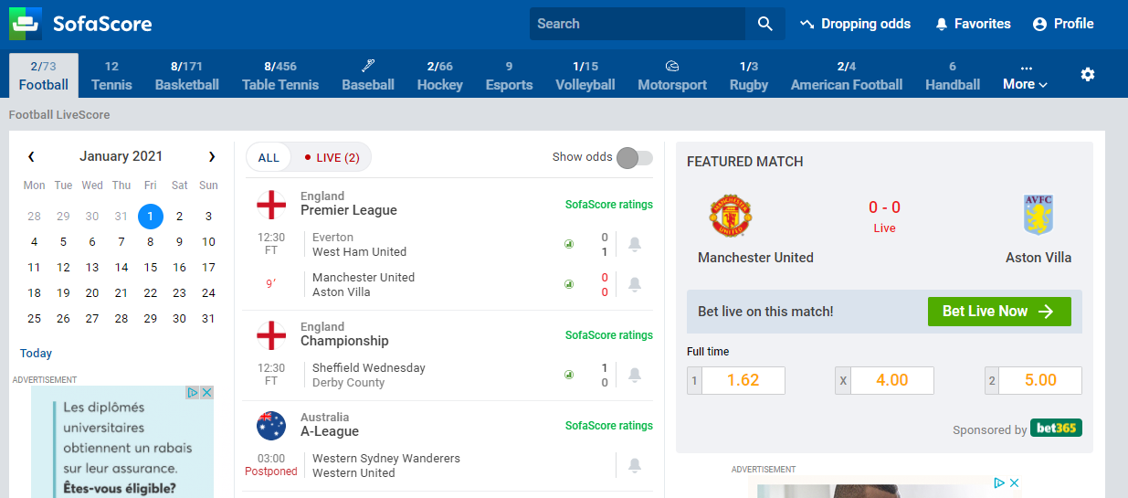

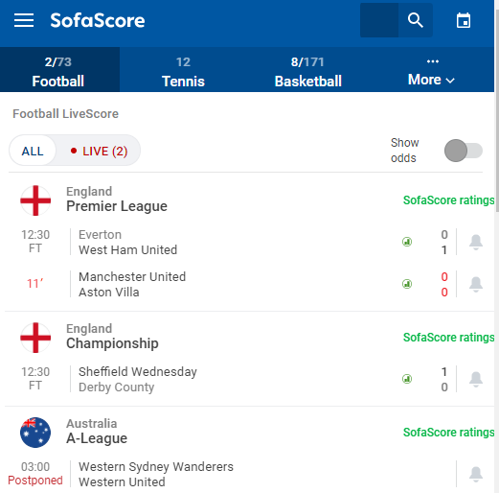

* 1. Scoreboard

# 

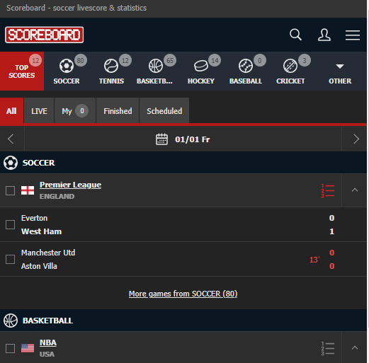

* 1. Euro 2020

# 

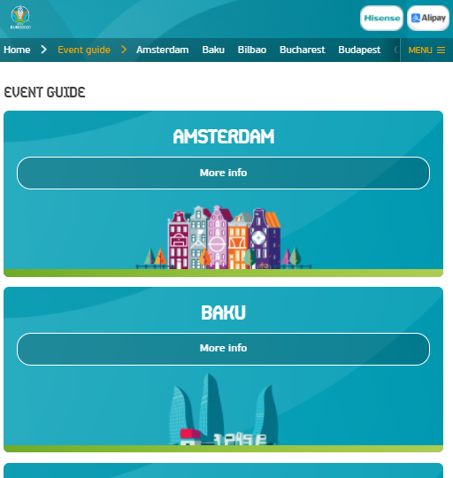

* 1. Paris-Nice 2020

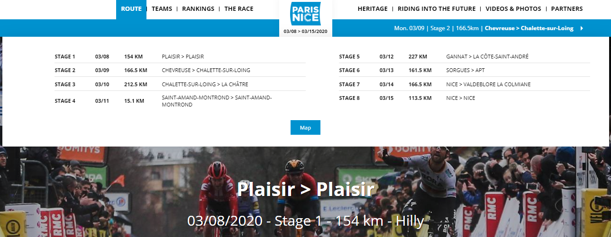

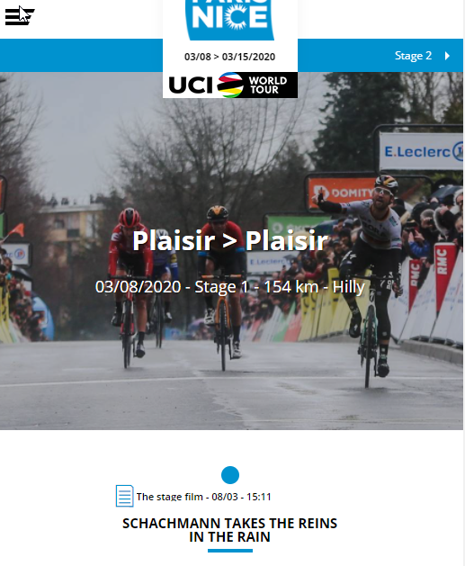

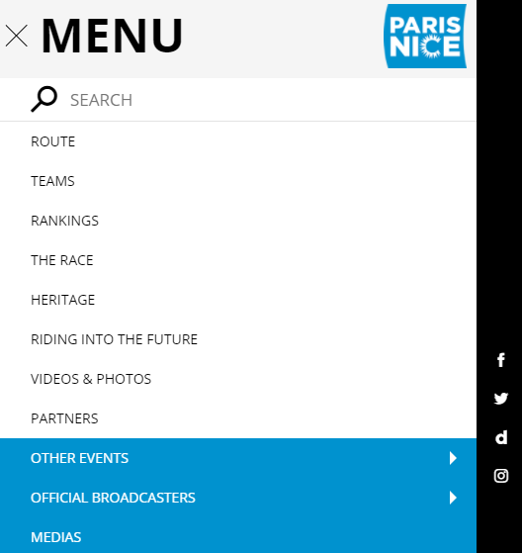

* 1. Sports Events 365

# 

